UNIVERSITY of DUBUQUE
Registrar’s Office
ONLINE GRADE ENTRY
Accessing MyUD:
- To access the MyUD login screen, type “my.dbq.edu” in your web browser navigation bar. (We encourage you to use Mozilla Firefox or Google Chrome.)

- Once you reach the login screen, you can review additional instruction links, or you can login at the upper-right corner of the screen. The UD Login is your Network User Login (your first name initial and your last name). The Password is your UD Network password.

- If you are unsure of your Network login information, you can call the HelpDesk at 589-3737 or contact them via e-mail at HELPDESK@dbq.edu.

- Please note: the “Back” button of your web browser will not work in MyUD. Always use the path links at the top of the page.

Grade Entry:
  - Faculty can access grade entry via MyUD under the Faculty Tab (see below):
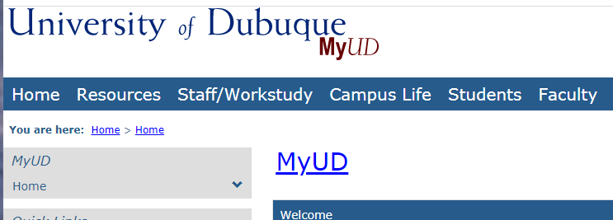

  - You can then click on the Grade Entry link in the left side column of options (see below) 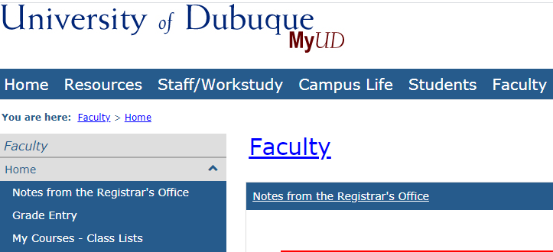
- The View Course List link will open up a list of your courses. Select the appropriate term from the Term drop down menu.
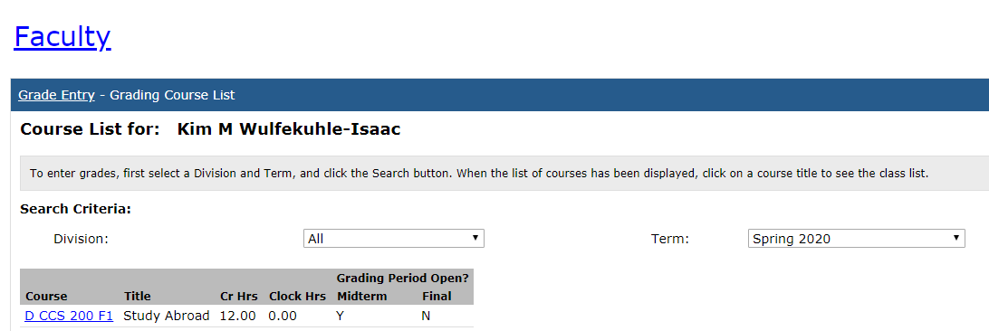
- If grade entry is open, there will be a ‘Y’ under Midterm or Final Grade (Half-semester classes will not have mid-term grades.) Next step is to click on the Course number for which you want to enter grades.
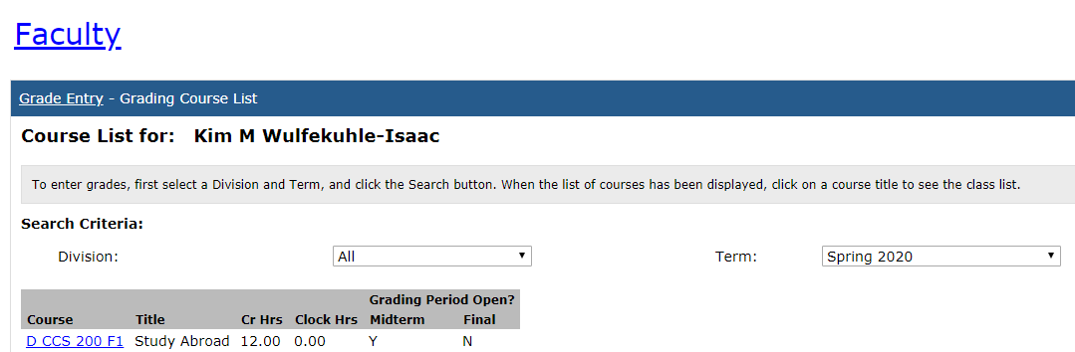
- You have now arrived at the grade entry screen. Enter the grade for each student by using the drop-down menu or typing it in directly.
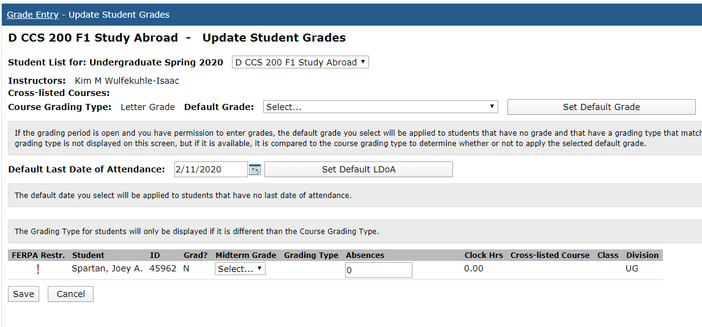

Important notes about the grade entry screen:
  - Do not use the Default Last Date of Attendance feature. Only record a Last Date of Attendance for an individual if s/he stopped attending the class.
  - W (Withdrawn) and I (Incomplete) grades are not an option for online grade entry. W grades will be entered in the Registrar’s Office at the point the Withdrawal card is received. If a student has officially withdrawn through the Registrar’s Office, a W grade will appear on the screen as the grade.
If there is not a W grade on the screen and the student stopped attending, enter the student’s last date of attendance in the attendance column, and submit the grade earned.
I (Incomplete) grades will be entered in by the Registrar’s Office at the point the Request for Incomplete form is received from the instructor.

  - If you have entered a grade and want to remove it, click on “Select” in the dropdown menu of grades. You can click the “Cancel” button at the bottom of the screen, but this will remove ALL grades!
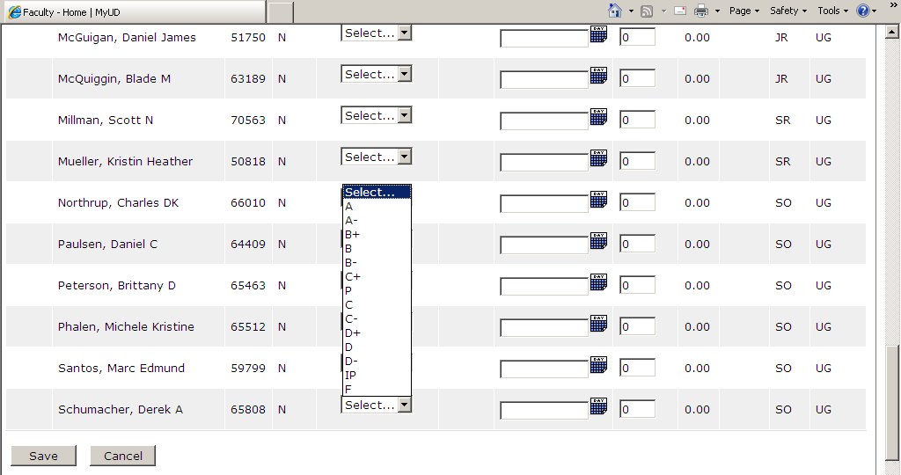

  - To submit your grades, click on SAVE at the bottom of the page. Please remember: this is the only page to “proof” your grades before submitting. A grade cannot be changed via computer after submission, and you will need to complete the Change of Grade Form found under the Forms in MyUD.

  - After submitting your grades, a new window will open listing all grades. If you would like to print a copy for your own records, you may click on the Printer Friendly link at the top of the page. On the next window, click the Send to Printer button. Exit Print Mode when finished.
  - To enter grades for another class, click on the Grading Course List link at the top of the Grade Entry page.
  - 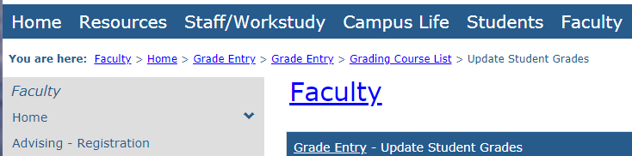
Things to Remember:
  - If a student has officially withdrawn from the class (through the Registrar’s Office), a ‘W’ will appear as the grade. If there is not a ‘W’ grade, and the student stopped attending, enter the student’s last date of attendance in the attendance column and submit the grade earned.
  - An Incomplete grade cannot be recorded until an Incomplete Grade Request form is on file in the Registrar’s Office. (This form is found at: http://www.dbq.edu/Academics/Registrar/Forms/). Students must initiate this request
  - A student attending class but not appearing on your grade list is not registered or may be registered in the wrong section. Notify the Registrar’s Office, and ask the student to see the Registrar’s Office immediately regarding his/her registration.
  - If a student is listed who has never attended, please contact the Registrar’s Office immediately as this information should have been reported during the first two weeks of the term.
If you have any additional questions, please contact Kim Wulfekuhle-Isaac at Ext. 3178 or Amanda Yarolim at Ext 3478.

